AIR DATA PITOT STATIC TEST SETS

To verify the correct function of the Air data Computers and Instruments maintenance facilities needs the appropriate equipment. This equipment is used:
- To read the errors of Altimeter and Airspeed-Indicators.
- After disconnection of Pitot/Static-Lines leak test must be performed.
The art of test equipment has a wide variation. Roller-Pumps (for leak-test only). Hand-driven Pumps, electric driven and computer controlled units are available.

- For all pitot- and static-test use approved adapters for connecting the hoses to pitot tubes and static ports. If connections inadvertent falls off, damage of the instruments or airdata computers can be the result!
- Drain holes and opposite static ports must be closed during test. Don't forget to remove the adhesive red tape or adapter after the test is finished!

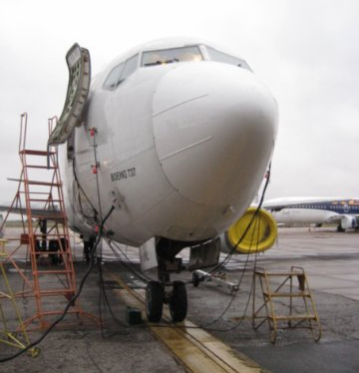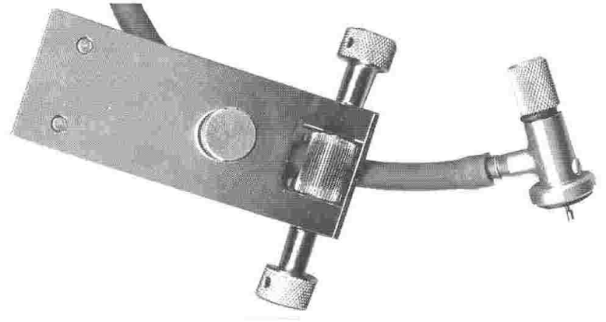
Figure: Roller Pump with Static Port Adapter (Used for Leak Test only)

Manually operated Test Set
There is a wide variety of different testers varying from those with hand pumps to those with electric pumps and computers.
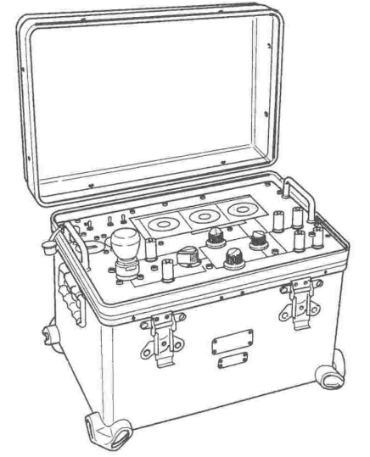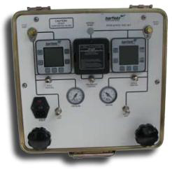
Figure: Sextant 301 Tester with Hand Pump and Electronic Displays

Example: Static pressure: 20'000 ft
Pitot pressure: 320 kts
maximum Leak rate: 100ft/min 2kts/min

Pressurized Air Supply
The air supply unit provides the following functions:
- generating the high pressure (HP) and low pressure (LP): a single manual pump fitted with intake and outlet valves and filters, connected to a pressure reducer and two air chambers generates the HP and LP,
- air pressure selector: the selector provides a choice between HP and LP and also return to atmospheric pressure (ATM),
- intake and balancing: intake of the available HP and LP and the ATM pressure is achieved by means of two valves which are used to vary Ps and Pt; a balancing valve is used to balance Ps and Pt; these valves are fitted with micro-metric screws allowing very fine adjustment,
- pneumatic safety devices: pneumatic filters, self-sealing pressure couplings with locating ins and a safety valve protect both the generator itself and also the tested circuits.
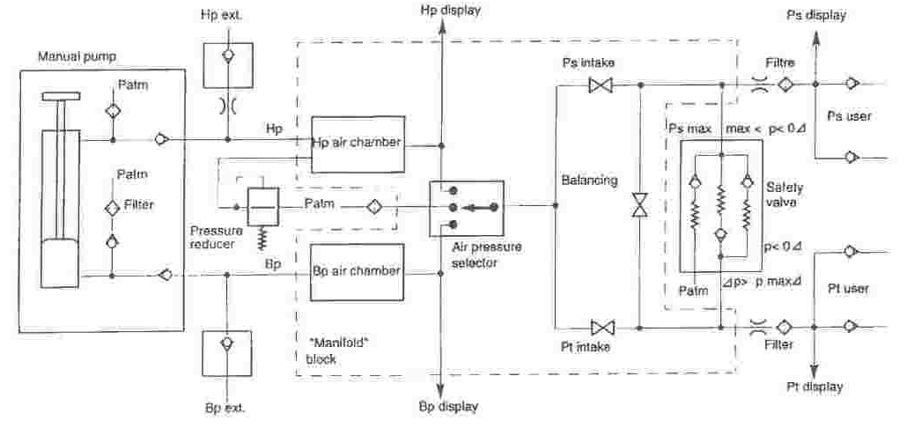
Figure: Sextant 301 Pressure/Vacuum System

If static pressures tests over 10'000 ft has to be performed, Pitot (Pt) must also be connected to the pitot tube, to prevent damage of airspeed indicators and airdata computers.
Via balancing valve the static pressure is equalized to both side of pressure diaphragm inside aircraft instruments and computers

Electronic Unit
This unit comprises two main sub-assemblies:
- acquisition, processing and display electronics comprising:
- a digital LCD
- pressure acquisition and processing electronics
- 4 pressure sensors
- power supply electronics comprising:
- a rechargeable battery under 28 V
- charging electronics
- an electrical power supply
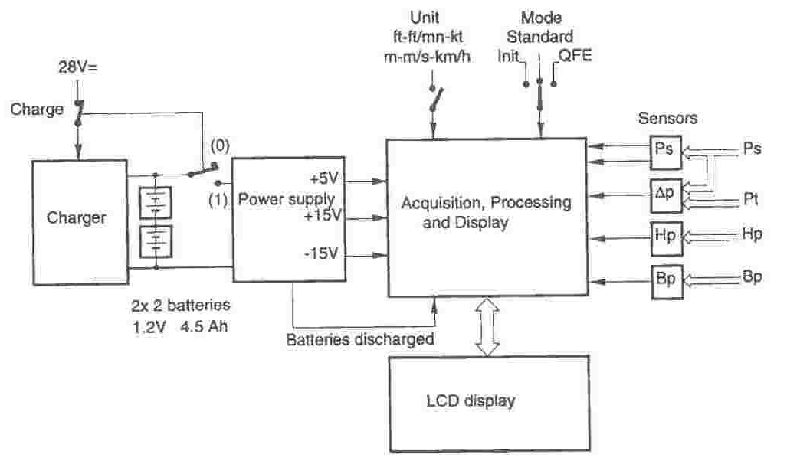
Figure: Sextant 301 Electronic System

Air Data Tester Front Panel (Sextant 301)
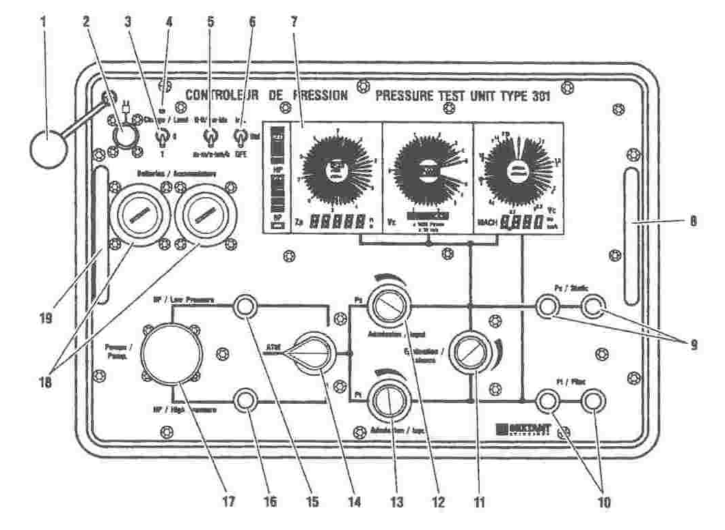
Figure: Sextant 301 Air Data Tester Front Face

The painted front panel plate is labelled in two languages and comprises:
- Self-sealing static pressure Ps output couplings with locating pins 9
- Self-sealing total pressure Pt output couplings with locating pins 10
- Handle for manual actuation of the pump supplying the HP and LP 17
- Pressure selector 14 providing an HP, ATM pressure or LP intake in the two channels Ps and Pt
- Static pressure Ps intake valve 12
- Total pressure Pt intake valve 13
- Balancing valve of the two pressure channels Ps and Pt 11
- Connector for the external 28 VDC electricity supply 2 with a connector cover 1 for storage battery versions
- Front panel cover 21 for versions without the connector
- Power switch:
3-position: Charge, 0 (off), 1 (on) connected to an LED 4 that lights up during the battery charging time for storage battery versions 3
2-position: 0 (off), 1 (on) for primary battery versions 20
- 2-position unit selector: ft ft/min kts or m m/s km/h 5
- 3-position switch with 1 unstable position: Init and 2 stable positions: Std (Standard), QFE 6
- Digital display block 7
- 2 compartments for storage batteries 18 or primary batteries 22 depending on the version
- Pressure coupling for an externally generated HP 15
- Pressure coupling for an externally generated LP 16
- Carrying handles 8 and 19

Automatic Air Data Tester (Sextant 410)
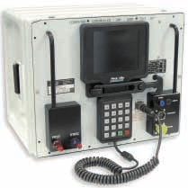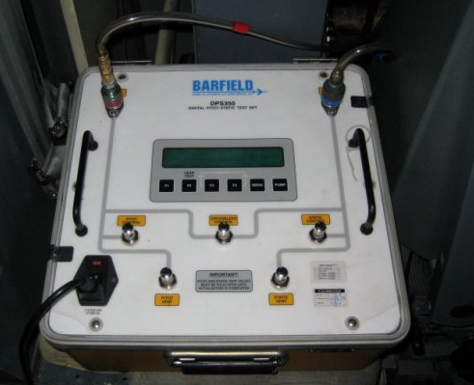
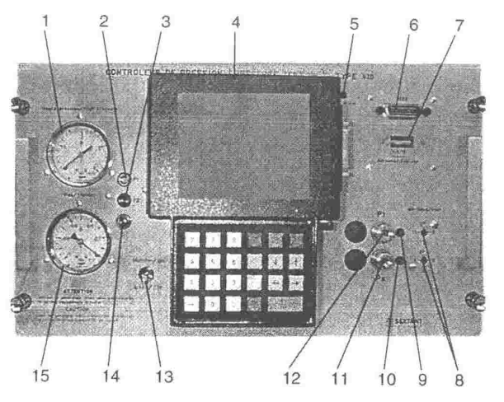
Figure: Sextant 410 Air Data Tester Front Face
Pressure test unit:
1. High pressure gauge showing the high pressure HP.
2. Fuse 1A to protect 9 VAC (RCDU power supply).
3. Fuse 1. 5A mains protection.
4. Remote Control Display Unit.
5. Failure warning light.
6. IEEE connector (to connect an external computer with standard IEEE port).
7. Address switches (used to select address in automatic mode.
8. Openings using screwdrivers to the Ps and Pt channel venting valves.
9. Pt warning light (Pt pressure is available).
10. Ps warning light (Ps pressure is available).
11. Black Ps self-sealing pneumatic coupling.
12. Red Pt self-sealing pneumatic coupling.
These needle valves can be separately adjusted by the user in order to select the venting speed.
13. On/Off switch.
14. Main Power on indicator light of the generator.
15. Vacuum gauge showing the low pressure value BP.

Remote and Control Display Unit
The man-machine interface was developed based on a software using multiple windows with drop-down menus activated by the operator.
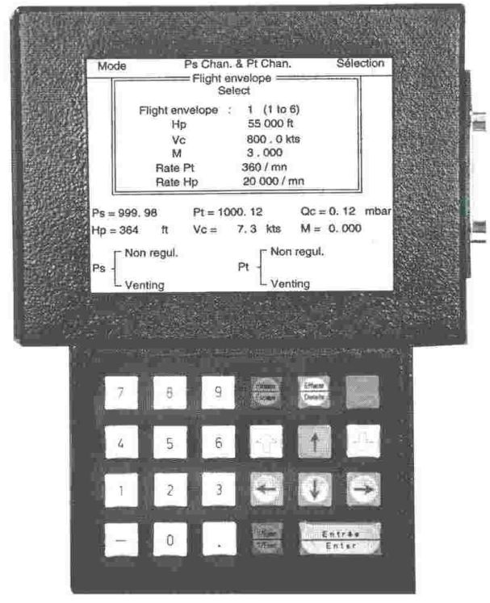
Figure: Sextant 410 RCDU

The RCDU is made up of.
- 320 x 240 pixel monochrome screen managed in graphic mode
- Keypad with 23 keys
- Potentiometer for adjusting brightness
- Connector for a parallel output (printer)

The screen is composed of:
- 12 keys. 0 . .9 used to define the order values, program and acceptance numbers.
- ESCAPE used to Exit from the window displayed and return to the menu at a higher level menu.
- DELETE used to delete the last numerical value entered and not yet validated. It can also be used to delete line in certain auxiliary functions.
- PAUSE used to stop the change in progress when in generator mode.
- UP and DN keys used to change zones in a window and to decrease or increase the generated pressures.
- 4 keys: UP, DN, LH and RH used to move the cursor in a menu.
- ? / EXEC used for obtaining information if there is an error message (M ?) or for executing an order (EXEC).
- ENTER used to validate the current command or value.

The screen is made up of three main zones:
- A menu bar with three functions:
-Mode, Channel select status (Ps and Pt)
-Selection
-Menus associated with the different functions
  - QFE display if operation in QFE mode is selected
  - The permanent display of the following parameters:
- Ps, Pt, Qc, Hp, Vc and M and the status of the Ps and Pt channels.

