1. ATC Transponder / DME Tester

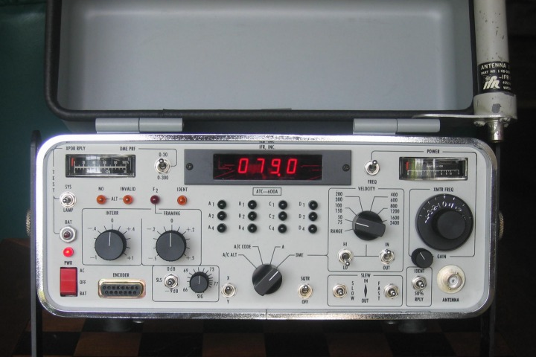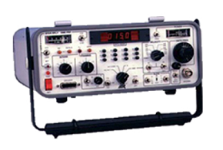
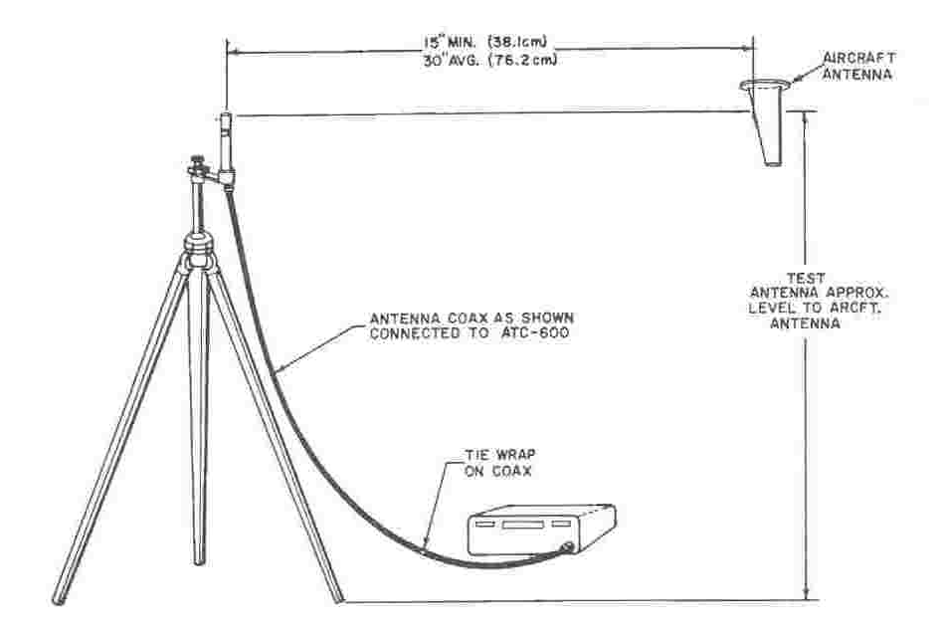
Figure: ATC-600 ATC-DME Tester with Antenna

The ATC-600 is designed for ramp use and is capable of exacting functional test of aircraft transponder (XPDR) and distance measuring equipment (DME) systems.
The test set contains built-in signal generators and modulators for XPDR and selected DME frequencies. Its radio frequency (RF) output is coupled to airborne equipment by a remote tripod mounted antenna system. Functional bench testing requires a 34 dB external attenuator and a three foot coaxial cable between the test set and the unit under test.
The type of transponder interrogation desired is selected from Modes. A/C ALT aircraft altitude and A/C Code aircraft code.
The A/C ALT Mode displays the altitude code.
The A/C CODE Mode displays the pilot's code. Code pulses and numerical readout are displayed simultaneously in all modes.
FREQ/PWR Meter indicates peak RF power and the transmitter frequency of the unit under test.
TXPDR/ RPLY/DME PRF Meter indicates XPDR percent reply and DME interrogation pulse repetition frequency (PRF).
Interrogation Spacing Control allows precise checking of the XPDR input pulse decoder gate.
FRAMING Pulse Spacing Control allows checking of the F2 pulse width and its position relative to F1.
Front Panel Altitude ENCODER Input Connector allows altitude display from an encoding altimeter without a transponder.
DME fixed range is variable from 0 to 399.0 NM and velocity from 50 to 2400 knots.
X Channel (108.00 or 108.10 MHz paired channel) and Y Channel (108.05 MHz paired channel) are provided.
An internal Ni/Cd battery permits ramp operation for over two hours. A built-in charger functions when the set is connected to an ac line.

2. ATC / TCAS Tester

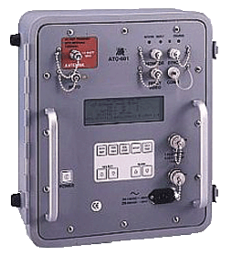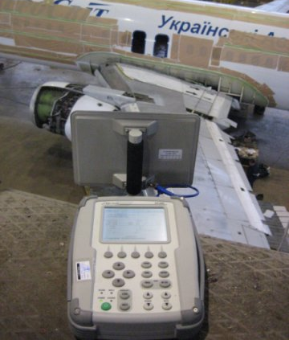
Figure: TCAS 201 and TCAS 601 Ramp Test Sets with Antenna

The TCAS-201 Ramp Test Set provides three simulations:
- Active Mode C or Mode S Transponder transmits continually changing replies to interrogations from a specific TCAS interrogator or unit under test.
- Mode C or Mode S Reply Generator transmits preset replies to interrogations from a specific TCAS interrogator.
- TCAS Interrogator Monitor decodes information from interrogations received from any interrogator transmitting in the operating mode of the tester.
Interrogations are received on an RF carrier Signal at 1030 MHz. through the RF I/O Connector or ANTENNA Connector.

Scenario Test
The TCAS-201 simulates a moving mode C or mode S transponder when scenario test is initiated. Once a second, the tester calculates a new position for the test. Using range rate information from the Scenario Test Screen, the tester calculates and implements a new reply delay for simulating the updated position. Using the altitude rate from the Scenario Test Screen, the tester calculates new altitude data for the next Mode C or Mode S reply. Screen edits are incorporated at any time during operation.
Reply Test
The TCAS-201 simulates a stationary Mode C or Mode S transponder (reply generator) when Reply Test is initiated. The tester sets replies according to information loaded into the applicable Reply Test Screen. Information is updated only when edits are made to the Reply Test Screen.
Monitor
The TCAS-201 monitors the Whisper-Shout sequence in ATCRBS operation and interrogations including the TCAS Broadcast in Mode S operation.
Power & Frequency
Power & Frequency is a cyclic program. The test transmits Mode S squitters starting with the address loaded in the Mode S Reply Test Screen.
Positioning of the Antenna
For proper results the test set antenna must be in sight' of the ATC or TCAS antenna. The Mode-S transponders and the TCAS computer are connected to two antennas, that both must be able to exchange valid signals, only one antenna may be checked at a time. Thus the antennas must be in the signal beam of the test set one by one. During testing the upper antenna, the lower one must be shielded. But shielding the upper antenna during the lower antenna test is not so easy. Using the aircraft fuselage as a barrier between the test set and the upper antenna solves the problem.
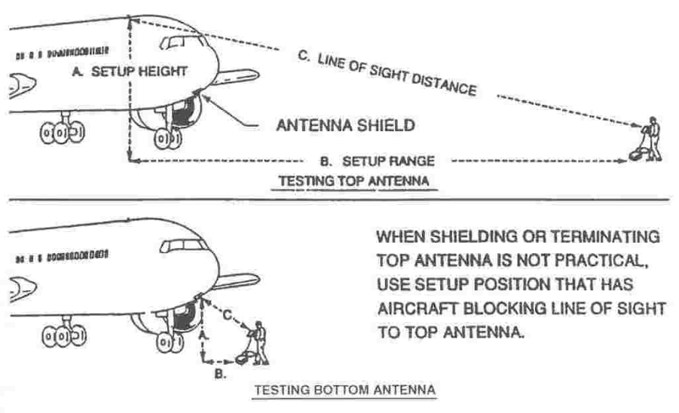
Figure: Testing of upper and lower antenna

The position of the test set is not too critical. For optimum results however, obstacles must be located outside the main antenna lobe Distance to the antenna must be between 6 and 300 feet (1,8 to 90 meters). Signal strength is adjusted automatically.
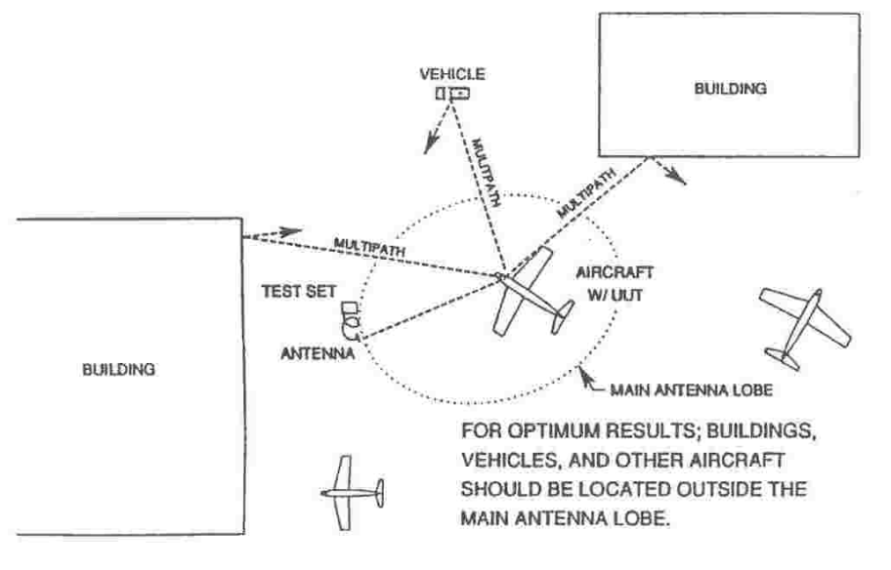
Figure: Avoiding of signal reflections

