PRACTICAL CLASS 3.4

Theme: Fundamentals of structural systems of helicopters

3.4.1. Specific helicopter components (Bell UH-1C)
Here are some of the component parts that make up a helicopter. While this is an example of one specific helicopter (Bell UH-1C), not all helicopters will have all of the parts listed here. Some of this may be a bit more of the same old stuff we have just discussed, but it will show everything as it relates to everything else on the aircraft and the location of each component.
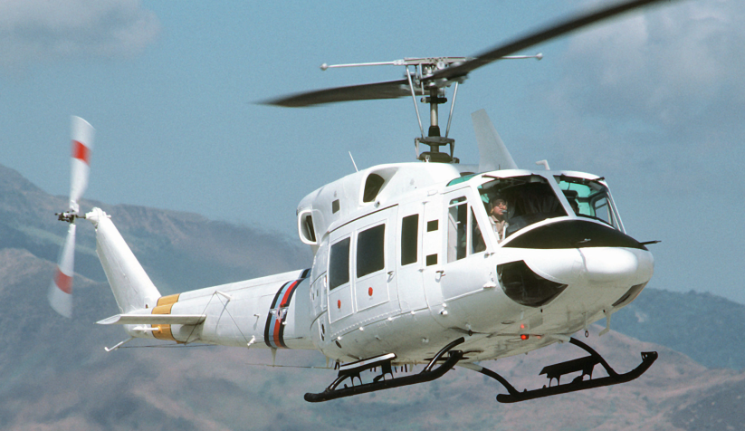
Figure: Bell UH-1C
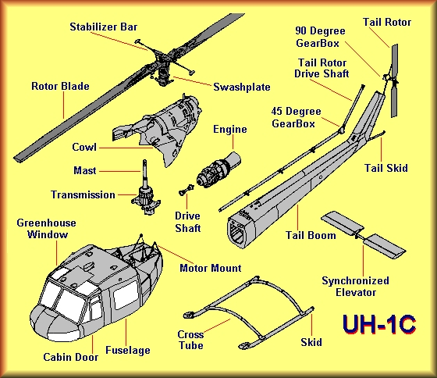
Figure: Anatomy of a Helicopter “Bell UH-1C”

Helicopter Bell UH-1C components:
- Rotor Blade: The rotary wing that provides lift for the helicopter.
- Stabilizer Bar: Dampens control inputs to make smoother changes to the rotor system.
- Swashplate: Transfers non-moving control inputs into the spinning rotor system.
- Cowling: The aerodynamic covering for the engine.
- Mast: Connects the transmission to the rotor system.
- Engine: Provides power to the rotor systems.
- Transmission: Takes power from the engine and drives both rotor systems.
- Greenhouse Window: A tinted window above each of the pilot seats.
- Fuselage: The body of the helicopter.
- Cabin Door: Allows access to the cabin and cockpit.
- Skids: Landing gear that usually have no wheels or brakes.
- Crosstube: The mounting tubes and connection for the skids.
- Motor Mount: A flexible way to attach the engine to the fuselage.
- Tailboom: Also known as an "empenage" is the tail of the helicopter.
- Synchronized Elevator: A movable wing that helps stabilize the helicopter in flight.
- Tailrotor: Provides anti-torque and in-flight trim for the helicopter.
- Tail Rotor Driveshaft: Provides power to the tailrotor from the transmission.
- 45 Degree Gearbox: Transfers power up the vertical fin to the 90 degree gearbox.
- 90 Degree Gearbox: Transfers power from the 45 degree gearbox to the tailrotor.
- Vertical Fin: Holds the tailrotor and provides lateral stabilization.
Tail Skid: Protects the tailboom when landing.

3.4.2. Flying a helicopter
A helicopter creates lift in a different way. Where a fixed wing aircraft has to be moving to produce lift by the "plane" or angle of attack on the wing, a helicopter achieves it by manipulating the main rotor blades, changing the angle at which they meet the air and subsequently the angle of attack. The drawback with this setup is the need for torque control with a tail rotor, which bleeds power from the engine every time it's used. That becomes a factor when pilot start getting into advanced manoeuvres.
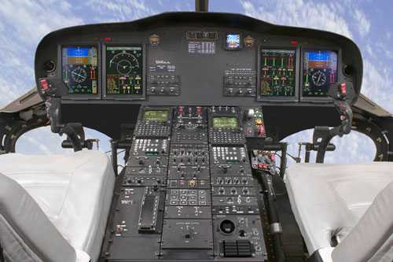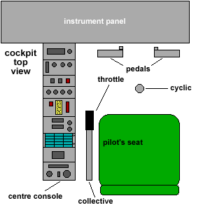

The throttle control is a 'twist-grip' on the end of the collective lever and is linked directly to the movement of the lever so that engine RPM is always correct at any given collective setting. The pilot only needs to 'fine tune' the throttle settings when necessary.

Airspeed
Controlled with pitch - While maintaining altitude, move the cyclic to change the airspeed. This requires a little coordination, similar to the throttle and yoke in a fixed wing. In level flight pilot increase collective/move the cyclic forward to speed up, reduce collective/pull the cyclic back to slow down. As pilot approach pilots desired speed, pilot have to adjust the collective to maintain it. It's a good idea to practice since pilot'll do this every time pilot takes off or land.

Altitude
Controlled with power - Pull the collective up to increase climb rate, lower it to increase descent rate. This is combined with cyclic movements to produce constant speed climbs and descents or level flight. While at cruise altitude and power, any minor altitude adjustments can be made with the cyclic only.
Behaviour
Helicopters are highly sensitive to input and very responsive. Slight pressures are required to master the finer techniques in hovering and landing.
Most helicopters have no form of adjustable trim. For example, if pilot pitch down when levelling off from a climb, the aircraft will continue descending unless pilot make an opposite cyclic input from the neutral position. This characteristic applies to forward, backward and sideways flight, and on a smaller scale in a hover.
Performance in any "mode" will be more responsive to input. Whereas a fixed wing may become sluggish and hard to control at slow airspeeds a chopper stays just as responsive if not more so.
Power reductions require some attention. The main rotor blades are pilots only means of creating lift, so if pilot drop the collective completely there's nothing holding pilot up, even though the throttle is wide open. All helicopter pilots are taught to "glide" the helicopter with little or no power to the ground.
Winds and turbulence play a large role in how pilot control and master the dynamics. Much as a fixed wing takes off in the direction of wind so too should pilots chopper.
One of the things that remain constant in fixed and non-fixed wing aircraft is that in a turn pilot loose altitude and go nose down without correction. This doesn't apply to "side" stepping in a hover.

Takeoff
A normal takeoff is performed in the following fashion. First, pilot must make sure the throttle is all the way open (For a turbine powered helicopter, advanced properly for a reciprocating engine powered helicopter). Once pilot have established the proper operating RPM, then pilot can pull up slowly on the collective. As pilot increase collective pitch, pilot need to push the left pedal (In American helicopters...right pedal for non-American models) to counteract the torque pilot generate by increasing pitch. (In reciprocating engined models, pilot will advance the throttle as pilot increase collective pitch). Keep pulling in pitch and depressing the pedal until the aircraft gets light on the skids. Pilot may sense a turning motion to the left or right, if so, pilot may need more or less pedal to maintain heading.
The cyclic will become sensitive and (depending on how the aircraft leaves the ground heels or toes of the skids last) as pilot continue to pull in pitch and depress the pedal, pilot will put in the appropriate cyclic input to level the aircraft as it leaves the ground. As the aircraft eases into the air, forward cyclic will be required to start the aircraft in a forward motion. As the aircraft advances forward, it will gain speed until about 15 knots and then the aircraft will shudder a little as pilot transition through ETL (Effective Translational Lift...See the unique forces page for a more in depth explanation of ETL). As pilot transition through ETL, the collective will need to be reduced, the pedal will need less pressure, and the cyclic will need to be forced forward to counteract the force against the front of the rotor system.
Failure to push forward will result in an abrupt nose high attitude and a reduction in forward speed. After the shudder of ELT is experienced, pilot will see a marked gain in forward airspeed, a reduced need for pedal input and a reduced need for collective pitch as the rotor system becomes more efficient. The airspeed indicator will most likely jump from zero to 40 knots indicated airspeed and will smoothly advance as the aircraft goes faster. Now pilot has taken off and with a little release of forward cyclic pressure, the aircraft will establish a climb and continue to gain airspeed. At this point, the pedals are only used to trim the aircraft, and most manoeuvres are accomplished by using a combination of the cyclic and collective controls.

Climbs and descents
Over airports and flat ground pilot won't go wrong using the numbers in the pilot operating hand book. Climbs and descents over rough terrain generally don't work with those speeds - out of necessity they tend to be slower, and climbs tend to be steeper. There are a few things to watch in a steep climb. Try to maintain at least 15-20 knots indicated airspeed. Depending on the altitude, slowing to zero in a climb can result in an unplanned descent, and below 20 knots speed bleeds off quickly. Add collective carefully and don't exceed the limit of the yellow "max continuous power" range on the torque gauge.

Hovering
A big selling point of helicopters is that pilot can land in pilots backyard. Where then would be the best place to learn to hover? An airport with a 12,000' runway and a 7,500' crosswind runway. Pilot want a lot of open space where pilot guaranteed not to hit anything. Pilot want somewhere that neighbours won't complain about the noise. Pilot want somewhere with long sight lines to the horizon so that pilot won't concentrate pilots gaze in too close. Pilot want somewhere that pilot can get fuel when pilot run out. All roads lead to the big airport! Generally the tower and ground controllers will give pilot permission to practice hovering on whichever runway isn't be used that day and/or over a seldom-used taxiway.
Most instructors will start by giving pilot one control at a time. Pilot takes the antitorque pedals and they handle the cyclic and collective pitch. Pilot practice pedal turns. Then pilot take the collective while the instructor controls the cyclic and pedals. Pilot go up, pilot go down. Maybe pilot land. Then pilot take the cyclic and the instructor takes the other controls and ... 1 second later the helicopter is oscillating like crazy and pilot hear "I have the controls" in pilots headset. Any good instructor will alert pilot to the fact that pilot need to be very light on the controls: "pilot fly with pressures, not movements." The instructor will also tell pilot that there is a bit of lag between the time that pilot put in a control input and the time that the helicopter reacts. What most instructors won't tell pilot is how to deal with these facts.
Here are a few tips for handling the cyclic, which controls forward/back and left/right movement of the helicopter:
Focus pilots gaze at least 1/2 mile in the distance if the sightlines in pilots practice area are long enough.
As soon as the helicopter is handed to pilot it will start to drift to the right. The tail rotor is counterbalancing engine torque but at the same time is pushing the machine to the right. Expect to hold a little bit of left pressure on the cyclic to avoid this translational drift.
Don't put in and hold a control input pressure. Suppose the helicopter is moving forward a bit. Pilot press back on the cyclic and hold that pressure. One second later the helicopter has responded to the initial pressure by arresting its forward creep. One second after that the helicopter has responded to two seconds of continuous pressure by rushing backwards at a frightening clip. If the helo is moving forward, press backwards for a split-second then try to return the cyclic to a neutral position. See if the helicopter stops creeping. If so, great. If not, try another little stab of back pressure. Although every second or two pilot are doing something with the cyclic, in any given instant pilot need not be putting in any cyclic input. Nudge the cyclic and then return to centre. Nudge and then return.
After an hour or two the instructor might be doing more harm than good in handling the other two controls. Everything is cross-coupled so if he is messing with the collective or the pedals it will require pilot to take action with the cyclic. It is actually easier to handle all three controls because at least the machine isn't doing completely unpredictable things from pilots point of view.
Take a break every 20 minutes by practicing takeoffs, trips around the pattern, and approaches to landings.

Approaches
One of the keys to a good approach is maintaining visual contact with pilots landing area. It's impossible to adjust pilots descent rate correctly if pilot lose sight of it. Sometimes this means turning the nose slightly with the tail rotor to keep things in view. That comes with practice. Think of the approach as pilot might in a fixed wing by imagining a glideslope and a touch point that pilot want to arrive at.

Landing
1) Plan on being at about 200-500ft. above ground or obstacles .5km from the landing area. Try to gauge pilots rate of descent by a reference on the ground. If pilot reach this target altitude early, hold it until pilot reach about .2km from the landing area. With pilots first couple of tries remember to keep an eye on pilots airspeed. it's very common for pilot in training to overshoot the landing area.
2) Slow to 40 knots 35-37% at about .2km from the landing area and begin to slowly descend. Things will start to happen fast. Check pilots descent rate. It's very important that pilot don't let pilot vertical speed get past 300' per minute - adjust power as required. Obstacles permitting, pilot want to be roughly as high above ground as the width of the rotor blades when pilot arrive at the edge of the landing area. As pilot get closer and closer to the edge, gradually slow to 30, then 20. Pilot may loose sight of the landing area briefly while bringing the nose up to bleed off some of that airspeed. Whether pilot is descending or not while doing this, pilot'll still have to carefully coordinate pitch and power. Next to hovering, that's probably the biggest challenge of the approach. I
3) As pilot cross the edge of the landing area, pilot should be levelling off and continuing to slow below 10 knots. Pilot may have to reduce power slightly and bring the nose up to do that. Watch the ground to ensure pilot remain moving forward as pilot drift into position. When the exact spot pilot want to land on appears to slide beneath the nose, pilot'll be in a good position to reduce collective. Make sure pilots parking brake is armed.
4) Ease the cyclic back to bleed off any remaining momentum, then ease it forward again to level the attitude indicator when all forward movement stops. At the same time if the rate of descent is too much add some collective. Now it's just a matter of keeping an eye on drift and getting the wheels to make contact with the ground. Keep pilots rate of descent as low as possible. Have the Parking brake armed and reduce all power.

3.4.3. Self assessment questions

1. As the rotor head is tilted to travel forward, what happens to the rearward travelling blade's pitch angle?.
A. Increases.
B. Decreases.
C. No change.

2. Forces on a helicopter, in a power-on descent are.
A. lift, drag, thrust, weight.
B. lift, drag, thrust.
C. weight, drag, lift.

3. What is the swash plate on a helicopter used for?.
A. Control of the pitch of the rotor blades.
B. Control of the speed of the rotor blades.
C. Control of the flap of the rotor blades.

